Name: Adwait S Purao

UID no.=2021300101

Exp no.=2

Aim:To implement 4-bit,5-bit,8-bit comparator using given MSI

Software required: Proteus 8.6 proffesional

1.IC 7485

2.Logic Toggle

3.Logic Probe

4. DC generator

Theory:

Comparator

A magnitude digital Comparator is a combinational circuit that **compares two digital or binary numbers** in order to find out whether one binary number is equal, less than or greater than the other binary number. We logically design a circuit for which we will have two inputs one for A and other for B and have three output terminals, one for A > B condition, one for A = B condition and one for A < B condition.Basically it generates the desired signal (either low or high) at the output when compares two digital values provided at its input.

IC 7485

arrowCompares 4-bit Binary or BCD Codes and Outputs Greater, Less Than or Equal

arrowOutputs Directly Interface to CMOS, NMOS and TTL

arrowLarge Operating Voltage Range

arrowWide Operating Conditions

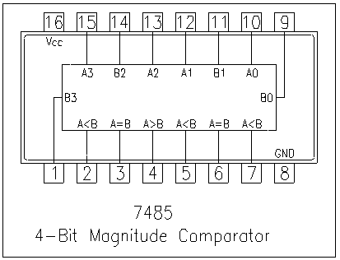

|  |  |
| --- | --- |
| **Pin Number** | **Description** |
| 1 | B3 Input |
| 2 | A<B Input |
| 3 | A=B Input |
| 4 | A>B Input |
| 5 | A>B Output |
| 6 | A=B Output |
| 7 | A<B Ouput |
| 8 | Ground |
| 9 | B0 Input |
| 10 | A0 Input |
| 11 | B1 Input |
| 12 | A1 Input |
| 13 | A2 Input |
| 14 | B2 Input |
| 15 | A3 Input |
| 16 | Vcc - Positive Supply |

Procedure:

1.Open Proteus 8 professional.

2.In the third column from the left,click on the P icon on the top left .

3.Type 7485,and click on the topmost option(4bit comparator),it would occur in the list.

4.In the same way bring Logic probe and Logic toggle to the list.

5.Click on Port icon on the leftmost bar and then click on Ground and add it to the screen.

6. .Click on the generator icon on the leftmost bar and then click on DC and add it onto the screen.